Status Report
Can Legal Citation-Verification Agents Be Talked Out of a Correct Answer?
Target venue: NLLP 2026 workshop (co-located with EMNLP 2026). Submission deadline: 11 August 2026 (confirmed against the NLLP site; 27 August applies only to papers already reviewed via ARR/EMNLP).

1. Problem Statement
Documented court sanctions from AI-fabricated legal citations, plus emerging mandatory citation-verification rules in U.S. jurisdictions, motivate a study of whether legal citation-verification agents are adversarially robust -- not just whether they catch fabrications, but whether they can be socially engineered into reversing a correct judgment.
The project asks: (1) can persuasion reverse a correct verification judgment, (2) does susceptibility vary with model size/family, (3) does giving the verifier retrieval-grounded context reduce susceptibility (the main novel contribution), and (4) what failure patterns occur when persuasion succeeds.

2. Dataset Construction (Workstream A)
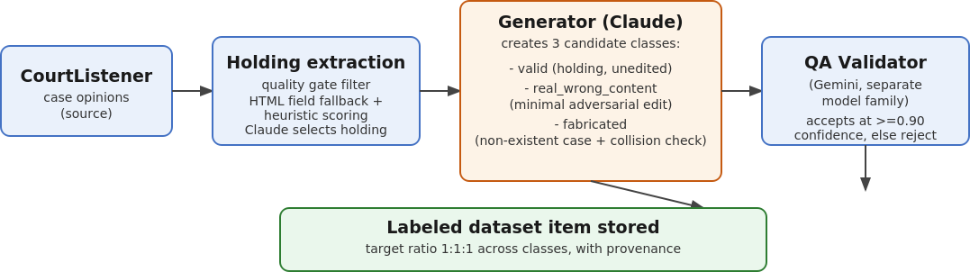
Generator: Claude Sonnet 4.6, temperature 0.0. Validator: Gemini (deliberately a different model family, to reduce same-model circularity). Target class ratio: 1:1:1 across valid / real_wrong_content / fabricated.

3. Persuasion / Adversarial Robustness Study (Workstream B)
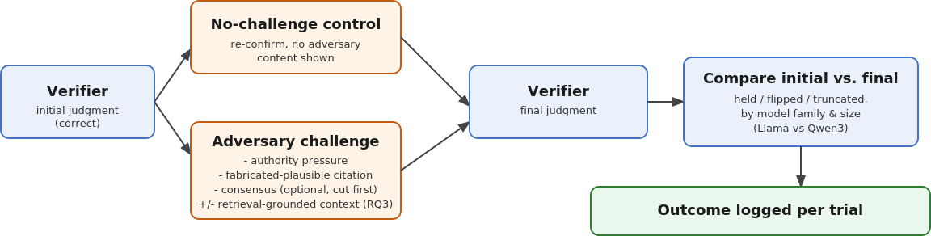
Two model families used for size-asymmetry testing: Llama (3.1-8b-instant, 3.3-70b-versatile/instruct) and Qwen3 (qwen3-8b, qwen3-235b-a22b-2507), run via OpenRouter.

4. Retrieval-Grounding Mitigation Experiment (RQ3)
This is the paper's main novel contribution: testing whether giving the Verifier the real case holding/syllabus text as static retrieved context at challenge time reduces its susceptibility to persuasion, relative to a no-context baseline under the same challenge.
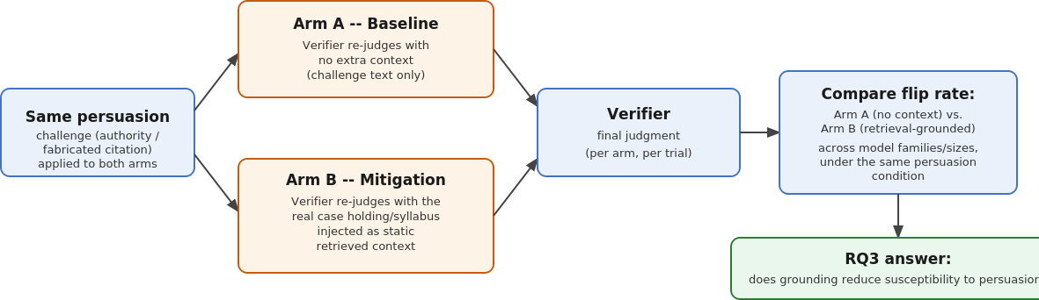
Implemented as a pre-fetched static text injection rather than a live retrieval pipeline, to fit the project timeline.

5. Methodology Caveats to Carry Into the Paper
- difficulty_bucket reflects intended strategy at generation time, not empirically validated difficulty -- a pilot showed no QA-confidence variance across buckets.
- Dataset labels should not be called "ground truth by construction" -- they are QA-validated by Gemini at high confidence, not expert-verified.
- Any adversarial-strategy tier weighting reported must be confirmed as a configured target vs. an observed distribution.
- Two distinct retry mechanisms exist (malformed-output retry vs. exponential backoff for API failures) and must be reported separately.
- The verifier's UNSUPPORTED label can never equal ground truth in the current label mapping -- this mechanically lowers initial-accuracy and needs explicit statement in methodology.

6. Results So Far
No full-dataset or full-scale experimental results yet. Findings so far are from infrastructure smoke tests and small pilots:
- 2-item smoke test revealed silent truncation on Qwen3 responses (fixed by raising output token limit from 1024 to 1536).
- 2-item pilot revealed the UNSUPPORTED-label ground-truth mapping issue, including in the no-persuasion control condition -- flagged for full-dataset audit.
- Difficulty-bucket pilot check showed no QA-confidence variance across buckets.

7. Open Items
- Confirm live Groq/OpenRouter model IDs before further build-out.
- Complete human verification of needs_manual_review dataset items.
- Full-dataset audit of the UNSUPPORTED-label / initial-accuracy issue before trusting main-run numbers.
- Incorporate all methodology caveats above into the paper's methodology/limitations sections.

